Panasonic Vietnam
Intelligent Document Processing (IDP)
Architecture Description Document

January 2026
Team 07
Document Version: 1.0
Date: March 2026

2. Conceptual Architecture

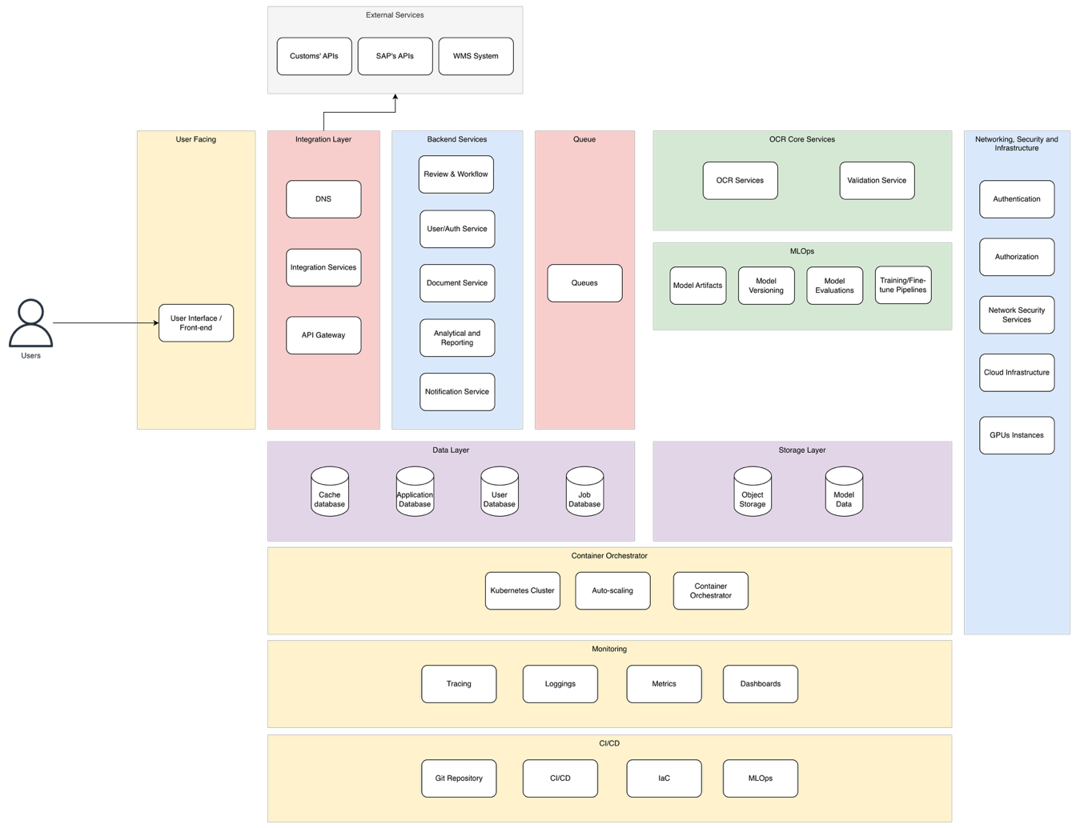

2.1 Overview
The Conceptual Architecture presents the IDP system as a set of logical layers and services, independent of any specific technology or cloud provider. This view establishes the structural decomposition of the system, defining clear boundaries and responsibilities for each component. The design follows a microservices architecture pattern with event-driven communication, enabling independent scaling, deployment, and evolution of individual services.

2.2 Layer and Service Descriptions
The following table describes each layer and its constituent services within the Conceptual Architecture. Each service is mapped to its functional responsibility within the IDP processing pipeline.

Layer | Service / Component | Description
External Services | Customs' APIs | Government customs portals for real-time declaration validation and compliance checks
 | SAP's APIs | Enterprise resource planning integration for financial data, invoice records, and accounting entries
 | WMS System | Warehouse Management System for inventory records, receipt documentation, and logistics data
User Facing | User Interface / Front-end | Web-based application for document upload, review, and dashboard access from desktop and mobile devices
Integration Layer | DNS | Domain name resolution for service routing and load distribution
 | Integration Services | Middleware layer handling communication between internal services and external systems (SAP, WMS, Customs)
 | API Gateway | Central entry point for all API requests with authentication, rate limiting, and request routing
Backend Services | Review & Workflow | Manages exception handling queues, document review interfaces, and approval workflows for flagged items
 | User/Auth Service | Handles user authentication, authorization, role-based access control (RBAC), and session management
 | Document Service | Core document lifecycle management including upload, storage, retrieval, classification, and metadata handling
 | Analytical and Reporting | Generates operational reports on processing volume, accuracy rates, error analytics, and cost savings dashboards
 | Notification Service | Delivers email and in-app notifications for review tasks, processing status updates, and system alerts
Queue | Queues | Message queuing for asynchronous processing of document extraction, validation, and integration tasks
OCR Core Services | OCR Services | AI-enhanced OCR engine with multilingual extraction (Vietnamese/English), confidence scoring, and field recognition
 | Validation Service | Cross-verification engine validating extracted data against business rules, reference data, and related documents
MLOps | Model Artifacts | Storage and management of trained ML model binaries, weights, and configuration files
 | Model Versioning | Version control for ML models enabling rollback, A/B testing, and model lineage tracking
 | Model Evaluations | Automated evaluation pipelines measuring model accuracy, drift detection, and performance benchmarking
 | Training/Fine-tune Pipelines | End-to-end pipelines for model retraining using human correction feedback and new document samples
Networking, Security & Infrastructure | Authentication | Identity verification including multi-factor authentication (MFA) for all user access
 | Authorization | Permission enforcement ensuring role-based access control with principle of least privilege
 | Network Security Services | Firewall rules, WAF, DDoS protection, and network segmentation for defense in depth
 | Cloud Infrastructure | Underlying compute, networking, and storage infrastructure provisioned on cloud platform
 | GPUs Instances | GPU-accelerated compute instances for OCR model inference and ML training workloads
Data Layer | Cache Database | In-memory caching for frequently accessed data, session state, and API response acceleration
 | Application Database | Primary relational database storing document metadata, processing state, and application configuration
 | User Database | Dedicated store for user profiles, roles, permissions, and authentication credentials
 | Job Database | Tracks asynchronous job status, processing queues, retry state, and task scheduling metadata
Storage Layer | Object Storage | Scalable blob storage for uploaded document images, processed outputs, and archival data
 | Model Data | Dedicated storage for ML training datasets, evaluation results, and model artifacts
Container Orchestrator | Kubernetes Cluster | Container orchestration platform managing service deployment, scaling, and health monitoring
 | Auto-scaling | Horizontal and vertical pod autoscaling based on CPU, memory, and custom metrics (queue depth)
 | Container Orchestrator | Container runtime and lifecycle management with rolling updates and zero-downtime deployments
Monitoring | Tracing | Distributed request tracing across microservices for latency analysis and bottleneck identification
 | Logging | Centralized log aggregation, indexing, and search for operational troubleshooting and audit compliance
 | Metrics | Time-series metrics collection for system performance, business KPIs, and SLA monitoring
 | Dashboards | Visualization layer providing real-time operational dashboards and alerting interfaces
CI/CD | Git Repository | Source code version control hosting application code, infrastructure definitions, and ML pipeline configurations
 | CI/CD | Continuous integration and delivery pipelines automating build, test, and deployment workflows
 | IaC | Infrastructure as Code managing cloud resource provisioning, configuration, and state management

2.4 Document Processing Flow
The core document processing pipeline follows this sequence:
Step 1 – Document Upload
- Users upload document images (PNG, JPEG, PDF, TIFF) through the web-based frontend, supporting both single and batch uploads (up to 50 documents per batch).
- The Document Service validates the file format, checks file size constraints (up to 10MB per file), and performs an initial image quality assessment (minimum 300 DPI threshold).
- If the image quality is below the acceptable threshold, the system provides real-time feedback with a quality score, prompting the user to re-upload.
- The original document image is stored in Object Storage (S3) with a unique document ID, and metadata (upload timestamp, user ID, file type) is recorded in the Document Metadata Database.
- A processing job is created in the Job Database with status "queued."
Step 2 – Document Classification
- The queued document is picked up by the OCR Core Services via the message queue (SQS).
- The system automatically classifies the document type — invoice, packing list, bill of lading, or warehouse receipt — with a target accuracy of ≥90%.
- Classification results and confidence scores are attached to the document metadata.
Step 3 – OCR Extraction
- The OCR Service extracts text from the document image using AI-enhanced multilingual OCR, supporting both Vietnamese and English with diacritical mark preservation.
- Key fields are identified and extracted: invoice number, date, amount, supplier name, line items, HS codes, and other document-type-specific fields.
- Each extracted field receives a confidence score (0–100%) based on OCR quality and extraction reliability.
- Extraction is completed within 10 seconds per document under normal load.
- Structured extraction results are stored in the Document Metadata Database and the job status is updated to "extracted."
Step 4 – Intelligent Validation
- Business Rule Validation: The Validation Service checks extracted data against predefined rules — format compliance, mandatory field presence, and data range constraints.
- Cross-Document Verification: The system cross-checks extracted data against related documents already in the system (e.g., invoice vs. purchase order, invoice vs. packing list) to detect discrepancies automatically.
- Reference Data Matching: Extracted values such as supplier names, product codes, and HS codes are validated against master data sources (supplier database, product catalog, customs reference tables). Unmatched entries are flagged.
- Validation results (pass/fail per check, specific error details) are attached to the document record.
Step 5 – Routing Decision
- Documents where all extracted fields score above the confidence threshold (≥70%) and pass all three validation checks are marked as "auto-approved" and routed directly to automated data entry.
- Documents with any field below the confidence threshold or any validation failure are flagged with specific issue details and routed to the Review & Workflow service.
- High-confidence documents that meet all validation criteria can optionally go through one-click approval by an authorized reviewer before data entry.
Step 6 – Human Review (if needed)
- Flagged documents appear in a prioritized review queue, sorted by business impact and urgency, with filtering capabilities.
- Reviewers see the original document image displayed side-by-side with the extracted data, with discrepancies and low-confidence fields highlighted.
- Reviewers can correct extraction errors, edit field values, override validation flags, or reject the document entirely.
- All corrections are tracked in the audit log with the reviewer's user ID, timestamp, original value, and corrected value.
- Approved corrections update the document status to "reviewed" and trigger the next step.
Step 7 – ML Feedback Loop
- Human corrections from the review step are automatically aggregated into a correction dataset.
- This dataset feeds into the MLOps training pipeline for periodic model retraining cycles, enabling the OCR and classification models to improve accuracy over time.
- Model versioning tracks each retrained model, and Model Evaluations benchmark new models against previous versions before promotion to production.
Step 8 – Automated Data Entry
- Validated and approved data is mapped to the target system schemas by the Integration Service.
- Data is pushed to external systems via API calls: SAP ERP (financial records, invoice entries), WMS (warehouse inventory updates, receipt records), and Government Customs portals (declaration validation, compliance submissions).
- All data insertions use atomic transactions with rollback capability — if any insertion fails, the entire transaction is rolled back with no partial data commits.
- Successful insertions update the document status to "completed" with transaction confirmation IDs from each target system.
Step 9 – Notification
- Email and/or in-app notifications are sent at key milestones: document upload confirmation, processing completion, review task assignment, approval/rejection status, and data entry confirmation.
- Error notifications are sent for failed transactions, including specific error details and retry instructions.
Step 10 – Audit & Reporting
- Every action across the entire pipeline is logged to the immutable audit trail: upload, classification, extraction, validation, review, correction, approval, and data entry — each with timestamp, user ID, action type, and data changes.
- Audit logs are retained for 7+ years to meet regulatory and compliance requirements.
- Processing metrics (volume, accuracy rates, error types, turnaround times, cost savings) are aggregated and available through the Analytical & Reporting dashboards.

3. Solution Architecture (AWS)

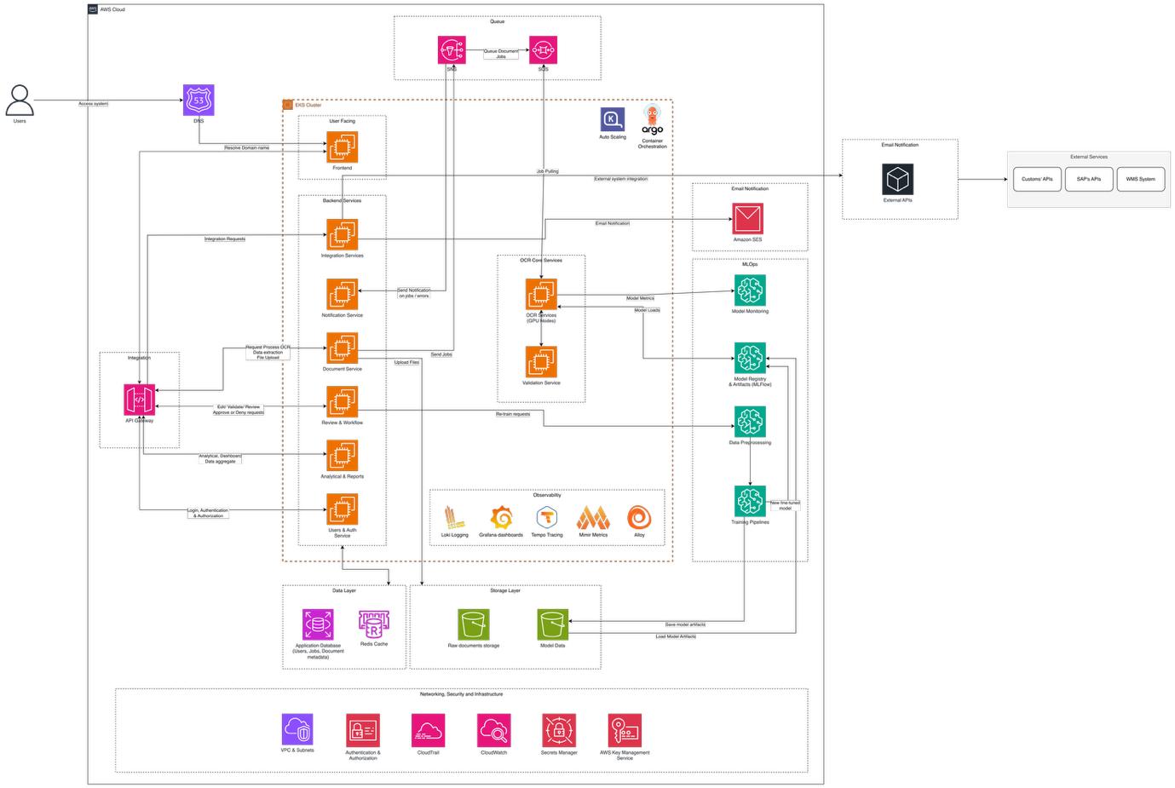

3.1 Overview
The Solution Architecture maps each logical service from the Conceptual Architecture to specific AWS managed services and open-source technologies. The implementation leverages AWS as the primary cloud platform, with Amazon EKS (Elastic Kubernetes Service) as the container orchestration layer running the majority of backend microservices. The observability stack is built on the Grafana ecosystem (Loki, Tempo, Mimir, Alloy) for unified monitoring, while CI/CD is driven by GitHub Actions with ArgoCD for GitOps-based Kubernetes deployments.

3.2 Service Mapping
The following table provides the complete mapping from logical services to AWS implementation, including a description of how each AWS service fulfills the corresponding architectural responsibility.

Layer | Logical Service | AWS Service | Description
User Facing | Frontend | EC2 Node on EKS | Static web / frontend deployed on EC2 nodes as a pod in EKS
Integration Layer | DNS | Amazon Route 53 | Managed DNS service with health checks and failover routing policies
 | Integration Service | EC2 Node on EKS | Serverless or containerized middleware handling external system integration logic
 | API Gateway | Amazon API Gateway | Managed API gateway with throttling, authentication, and request transformation
Backend Services | Review & Workflow | EC2 Nodes on EKS | Containerized microservice managing review queues and approval workflows
 | Users & Auth | EC2 Nodes on EKS | Managed identity provider with MFA, RBAC, and user pool management
 | Document Services | EC2 Nodes on EKS | Containerized service handling document lifecycle, upload, retrieval, and classification
 | Analytical & Reporting | EC2 Nodes on EKS | Containerized analytics service generating reports and dashboard data
 | Notification Services | Amazon SNS + SES | Push notifications via SNS and email delivery via Simple Email Service
Queue | SNS | Amazon SNS | Pub/sub messaging for event-driven notifications and fan-out patterns
 | SQS | Amazon SQS | Reliable message queuing for asynchronous document processing and task decoupling
Email Service | Email | Amazon SES | Transactional email delivery for review notifications and processing status updates
OCR Core Services | OCR Service | EC2 Nodes with GPU on EKS | Self-hosted models serve on EC2 nodes with GPU
 | Validation & Workflows | EC2 Nodes on EKS | Orchestrated validation workflows with cross-verification and business rule checks
MLOps | Model Registry & Evaluation | Amazon SageMaker + MLFlow | Model registry, versioning, and automated evaluation pipelines via SageMaker with MLFlow tracking
 | Training Pipelines | Amazon SageMaker | Managed ML training infrastructure with GPU instances and hyperparameter tuning
 | Data Preprocessing | Amazon SageMaker Batch Processing | Data transformation and preparation pipelines for training dataset curation
 | Model Monitor | Amazon SageMaker Monitor Job | Automated model drift detection, data quality monitoring, and performance alerting
Data Layer | Cache | Amazon ElastiCache (Redis) | In-memory caching layer for session management and high-frequency data access
 | User Database | Amazon RDS (PostgreSQL) | Managed relational database for user profiles, roles, and authentication data
 | Job Database | Amazon RDS (PostgreSQL) | Managed relational database for job tracking, queue state, and task scheduling
 | Document Metadata DB | Amazon RDS (PostgreSQL) | Managed relational database for document metadata, extraction results, and audit trails
Storage Layer | Object Storage | Amazon S3 | Scalable object storage with lifecycle policies for document images and archival
 | Model Data | Amazon S3 | Dedicated S3 buckets for ML training data, model artifacts, and evaluation datasets
Container Orchestrator | Kubernetes Cluster | Amazon EKS | Managed Kubernetes service for container orchestration with AWS integrations
 | Auto Scaling | Karpenter / HPA | Node-level scaling via Karpenter and pod-level scaling via Horizontal Pod Autoscaler
 | GitOps Deployment | ArgoCD | Declarative GitOps continuous delivery tool for Kubernetes application management
Observability | Logging | Grafana Loki | Log aggregation and querying system optimized for Kubernetes environments
 | Dashboards | Grafana | Unified observability dashboards for metrics, logs, and traces visualization
 | Tracing | Grafana Tempo | Distributed tracing backend for request flow analysis across microservices
 | Metrics | Grafana Mimir | Long-term metrics storage and querying compatible with Prometheus
 | Telemetry Collector | Grafana Alloy | OpenTelemetry-compatible collector for unified metrics, logs, and traces ingestion
Networking & Security | VPC & Subnets | Amazon VPC | Network isolation with public/private subnets, NAT gateways, and security groups
 | Authorization & Authentication | IaM | Fine-grained access control via IAM policies and Cognito user/identity pools
 | Audit Logging | AWS CloudTrail | API activity logging for governance, compliance, and operational auditing
 | Monitoring | Amazon CloudWatch | Infrastructure monitoring, log analysis, and automated alerting for AWS resources
 | Secrets Management | AWS Secrets Manager | Secure storage and rotation of database credentials, API keys, and certificates
 | Encryption Keys | AWS KMS | Managed encryption key service for data-at-rest encryption (AES-256) and envelope encryption
CI/CD | Source Control | GitHub | Git-based source code repository for application code and infrastructure definitions
 | CI/CD Pipelines | GitHub Actions | Automated build, test, and deployment pipelines triggered by code changes
 | IaC | Terraform | Infrastructure provisioning and state management via declarative configuration

3.4 Security Architecture
The security architecture implements defense-in-depth across all layers, addressing the requirements for encryption, access control, audit logging, and compliance:
- Network Security: Amazon VPC with public/private subnet separation. Backend services, databases, and ML infrastructure reside in private subnets with no direct internet access. NAT gateways provide controlled outbound connectivity. Security groups and NACLs enforce least-privilege network access.
- Data Encryption: All data in transit is encrypted using TLS 1.3 (NFR-011). All data at rest is encrypted using AES-256 via AWS KMS (NFR-012), including S3 buckets, RDS databases, and ElastiCache.
- Identity & Access: Amazon Cognito provides user authentication with MFA enforcement (NFR-013). AWS IAM policies enforce RBAC with least privilege for service-to-service communication (NFR-014). Kubernetes RBAC further restricts access within the EKS cluster.
- Audit & Compliance: AWS CloudTrail logs all API activity. Application-level audit logs are stored in immutable, append-only format with 7-year retention (NFR-017, NFR-018). AWS Secrets Manager handles credential rotation.
- Vulnerability Management: Automated security scanning of container images in CI/CD pipelines. AWS Inspector for infrastructure vulnerability assessment (NFR-016).

3.5 Scalability and Performance
The architecture is designed to meet the performance targets defined in the BRD while supporting 3x volume growth:
- Compute Scaling: EKS with Karpenter enables node-level auto-scaling based on pending pod demand. Horizontal Pod Autoscaler (HPA) scales individual services based on CPU, memory, and custom metrics such as SQS queue depth.
- Queue-Based Decoupling: Amazon SQS absorbs traffic spikes by buffering document processing requests. This ensures the OCR and validation services process at a sustainable rate without dropping requests during peak periods (NFR-004: 15,000 documents/day).
- Database Performance: Amazon RDS with read replicas handles query load distribution. ElastiCache (Redis) reduces database pressure by caching frequently accessed data such as user sessions and reference data lookups.
- Storage Scaling: Amazon S3 provides virtually unlimited storage with automatic scaling, supporting the projected 150GB+ annual growth (NFR-037) with no infrastructure changes.

3.6 Disaster Recovery
The disaster recovery strategy targets RPO of 24 hours and RTO of 4 hours (NFR-030, NFR-031):
- Database Backups: Automated daily RDS snapshots with cross-region replication for critical databases. Point-in-time recovery available within the backup retention window.
- Object Storage Durability: S3 provides 99.999999999% (11 nines) durability with cross-region replication enabled for document images and model artifacts.
- Infrastructure Recovery: All infrastructure is defined as code (Terraform/CDK) enabling rapid re-provisioning. ArgoCD automatically reconciles Kubernetes application state from Git.
- Failover: Multi-AZ deployment for RDS and EKS ensures automated failover within the primary region with less than 5 minutes of downtime (NFR-008).

4. Requirements Traceability
The following summarizes how the architecture addresses the key functional and non-functional requirements defined in the BRD and Requirements-Service Mapping:

4.1 Functional Requirements Coverage
- Document Upload (FR-001 to FR-003): Handled by Document Service running on EKS, with S3 for storage and real-time quality validation.
- OCR & Extraction (FR-004 to FR-008): Amazon Textract with custom post-processing on ECS provides classification, multilingual OCR, field recognition, and confidence scoring.
- Validation (FR-009 to FR-012): Validation Service on EKS with Step Functions orchestration. External API integration via Integration Service with mock endpoints for POC.
- Review & Workflow (FR-013 to FR-017): Review & Workflow Service on EKS providing exception queues, side-by-side review interface, manual correction, and approval workflows.
- Enterprise Integration (FR-018 to FR-020): Integration Service handling SAP and WMS API calls with atomic transaction management and rollback capability.
- Audit & Analytics (FR-021 to FR-025): Audit logging to PostgreSQL with immutable storage. Analytical Service providing dashboards, search, and reporting.
- User Management (FR-027): Amazon Cognito for authentication and RBAC with three role levels: uploader, reviewer, administrator.
- MLOps (FR-028): SageMaker + MLFlow pipeline capturing human corrections for periodic model retraining cycles.

4.2 Non-Functional Requirements Coverage
- Performance (NFR-001 to NFR-004): EKS auto-scaling, SQS queue buffering, and ElastiCache ensure sub-10-second OCR processing, 500+ concurrent users, and 15,000 documents/day peak capacity.
- Scalability (NFR-005, NFR-006): EKS with Karpenter and HPA supports 3x volume growth with automatic resource allocation.
- Availability (NFR-007, NFR-008): Multi-AZ deployment across all critical services targeting 99.5% uptime with less than 5-minute failover.
- Security (NFR-011 to NFR-016): VPC isolation, TLS 1.3, AES-256, Cognito MFA, IAM RBAC, CloudTrail, and automated vulnerability scanning.
- Compliance (NFR-017 to NFR-019): Immutable audit logs with 7-year retention, CloudTrail for API audit, and architecture supporting Vietnamese customs and tax regulations.
- Disaster Recovery (NFR-030, NFR-031): RPO 24 hours via automated RDS snapshots and S3 replication. RTO 4 hours via IaC-based infrastructure recovery and ArgoCD reconciliation.
- Cost Efficiency (NFR-040): Estimated infrastructure cost of $0.005–$0.01 per document processed, well within the $0.01 target, with annual operating costs of $8,000–$26,000.

